SMART SECURITY

INDRAJIT DUTTA -25

KIRTI BHUSHAN GANGULY-26

NILAY GHOSAL-27

DEBANJAN GHOSH -28

Under the guidance of

SUDIPTA DUTTA



**Mini Project Lab (EC681)**

**Department of Electronics and Communication Engineering**

**St. Thomas’ College of Engineering and Technology**

4, D. H. Road, Kolkata 700023

July, 2021

## Vision of the Department

* To build a strong teaching and research environment to cater to the manpower needs in Industrial and Academic domains of the rapidly growing Electronics and Communication Engineering.

## Mission of the Department

* To produce certified industry-ready professional in Electronics and Communication Engineering, though innovative educational programs in corporating laboratory practices and project-based teaching-learning processes, in a modern environment.
* To create knowledge base of advanced technologies through research in the area of Electronics and Communication, for competitive and sustainable development of the country.
* To groom the department as a learning centre to inculcate advancement of technology in Electronics and Communication Engineering with social values and environmental awareness.

## Program Specific Outcome (PSOs)

After completion of program, graduate engineer would have:

* **PSO1. Professional skills:** An ability to apply the knowledge in Electronics and Communication Engineering in various areas, like Communications, Signal processing, VLSI and Embedded Systems.
* **PSO2. Competency:** An ability to qualify at the State, National and International level competitive examinations for employment, higher studies and research

**1**

**PROGRAMOUTCOMES (POs)**

**Engineering Graduates will be able to:**

1. **Engineering knowledge**: Apply the knowledge of mathematics, science, engineering fundamentals, and an engineering specialization to the solution of complex engineering problems.
2. **Problem analysis**: Identify, formulate, review research literature, and analyze complex engineering problems reaching substantiated conclusions using first principles of mathematics, natural sciences, and engineering sciences.
3. **Design/development of solutions**: Design solutions for complex engineering problems and design system components or processes that meet the specified needs with appropriate consideration for the public health and safety, and the cultural, societal, and environmental considerations.
4. **Conduct investigations of complex problems:** Use research-based knowledge and research methods including design of experiments, analysis and interpretation of data, and synthesis of the information to provide valid conclusions.
5. **Modern tool usage**: Create, select, and apply appropriate techniques, resources, and modern engineering and IT tools including prediction and modeling to complex engineering activities with an understanding of the limitations.
6. **The engineer and society**: Apply reasoning informed by the contextual knowledge to assess societal, health, safety, legal and cultural issues and the consequent responsibilities relevant to the professional engineering practice.
7. **Environment and sustainability**: understand the impact of the professional engineering solutions in societal and environmental contexts, demonstrate the knowledge of, and need for sustainable development.
8. **Ethics**: Apply ethical principles and commit to professional ethics, responsibilities, and norms of the engineering practice.
9. **Individual and teamwork**: Function effectively as an individual, and as a member or leader in diverse teams, and in multidisciplinary settings.
10. **Communication**: Communicate effectively on complex engineering activities with the engineering community and with society at large, such as, being able to comprehend and write effective reports and design documentation, make effective presentations, and give and receive clear instructions.
11. **Project management and finance**: Demonstrate knowledge and understanding of the engineering and management principles and apply these to one’s own work, as a member and leader in a team, to manage projects and in multidisciplinary environments.
12. **Life-long learning:** Recognize the need for, and have the preparation and ability to engage in independent and life-long learning in the broadest context of technological change.

**2**

**Course Outcomes**

**After completion of the project, student will be able to:**

|  |  |  |
| --- | --- | --- |
| **Outcomeno.** | **Outcome Statements** | **Bloom’sLevel** |
| CO1 | Conceive a problem statement either from rigorous literature survey or from the requirements raised from need analysis | 5 |
| CO2 | Design, implement and test the prototype/algorithm in an innovative way to solve the complex engineering problems | 6 |
| CO3 | Apply technical knowledge in the solution of complex real-life problems | 3 |
| CO4 | Write comprehensive report on any project work | 6 |
| CO5 | Understand the impact of the suggested solutions in health, society, cost etc | 2 |
| CO6 | Apply the knowledge acquired during the project, in future higher studies or any professional job | 3 |

**Bloom’s Level:**

**Remember=1; Understand=2; Apply=3; Analyze=4; Evaluate =5; Create=6**

#### Project Outcomes Vs Program Outcome and Program Specific Outcome (PO) Matrix:

|  |  |  |  |  |  |  |  |  |  |  |  |  |  |  |
| --- | --- | --- | --- | --- | --- | --- | --- | --- | --- | --- | --- | --- | --- | --- |
|  | PO1 | PO2 | PO3 | PO4 | PO5 | PO6 | PO7 | PO8 | PO9 | PO10 | PO11 | PO12 | PSO1 | PSO2 |
| CO1 |  |  |  |  |  |  |  |  |  |  |  |  |  |  |
| CO2 |  |  |  |  |  |  |  |  |  |  |  |  |  |  |
| CO3 |  |  |  |  |  |  |  |  |  |  |  |  |  |  |
| CO4 |  |  |  |  |  |  |  |  |  |  |  |  |  |  |
| CO5 |  |  |  |  |  |  |  |  |  |  |  |  |  |  |
| CO6 |  |  |  |  |  |  |  |  |  |  |  |  |  |  |

**Certificate**

Department of Electronics and Communication Engineering

**St. Thomas’ College of Engineering and Technology**

This is to certify that the mini project titled “**SMART SECURITY**” has been carried out under my/our guidance.

<INDRAJIT DUTTA> (12200318056),

< KIRTI BHUSHAN GANGULY > (12200318053),

<NILAY GHOSAL> (12200318045),

<DEBANJAN GHOSH> (12200318060).

.

Dated:

……………………………………………….

MS. SUDIPTA DUTTA

(Project guide)

# Acknowledgement

**<PRITAM MUKHERJEE, SAIKAT DATTA.>**

……………………………………………….

Dated:

**2**

**Contents**

|  |  |  |
| --- | --- | --- |
| **Chapter No.** | **Chapter Name** | **Page No.** |
|  |  |  |
|  |  |  |
| **1** | **Introduction**  (<Project Overview, Objectives and Applications>) |  |
|  |  |  |
|  |  |  |
| **2** | **Background of the Project**  (<including Literature Survey and Review>) |  |
|  |  |  |
|  |  |  |
| **3** | **Details of the Project**  (<Block Diagrams/ Flow chart/Circuit Diagram/Layout Diagrams/Component List/ Algorithms/ Programs>) |  |
|  |  |  |
|  |  |  |
| **4** | **Results**  (<Tables/Graphs/Photographs/Results Analysis>) |  |
|  |  |  |
|  |  |  |
| **5** | **Comments on the results** |  |
|  |  |  |
|  |  |  |
| **6** | **Conclusion**  (Including Discussion & Future Works) |  |
|  |  |  |
|  |  |  |
| **7** | **Reference** |  |

**INTRODUCTION**

**PROJECT OVERVIEW:**

Security refers to providing an utmost protection to our well and important goods. It can be our home, documents, precious tools etc. Nowadays getting a security may be easy but getting a proper and best security is also necessary in case of some important places like banks, office, house, Jewellery shops, safe etc. As there are securities so there are intruders or Smart people to break through the security system.

**IMPORTANCE OF SECURITY:**

Smart home safety and security systems have gained much importance over the last few years owing to their notable impact in reducing and preventing losses in resources and human life caused by unwanted situations that could occur while homeowners are far away from their homes. To date, there is a lack of an in-depth literature analysis that could help researchers and developers better understand these systems and their applications in different contexts. It is therefore crucial that research evidence published in this area is presented. In this study, 63 research papers that examined smart home safety and security systems using the Arduino platform from popular literature databases were thoroughly surveyed to extract useful data. Then, the extracted data were analyzed to answer many research questions concerning state-of-the-art applications of these systems, their architectures, their enabling technologies, their components, etc. In addition, several challenges that these systems currently face and how future research could enable better implementation and use of these systems were discussed.

**APPLICATION:**

Security is a relative field, which can be applicable in any field, most primarily in protecting from foreign personal, and one of the major implementation is locking and unlocking in home, automobiles, office, safes etc. Since this project is based upon Security, the programmable electronic code lock device is programmed in such a way that it will operate only with the correct entry of predefined digits. It is also called an integrated combinational type lock which helps an individual to stay protected from unauthorized personel to enter into their premises.

**BACKGROUND OF THE PROJECT**

Our objective is to create a secure domestic and commercial system. Since we all have something important to us we want it to be protected like our home, merchandise, documents and so on depending upon the use of this system in any environment , our Smart Security is a low cost alarm based system working along with IOT cloud services which sends a notification to the admin or user of this system in case of a break in or in case of a gas detection. There are many products in the market like our product but what makes our product different is it’s application in any environment .

|  |  |  |  |
| --- | --- | --- | --- |
| **Product** | **Ozone Smart Digital Door Lock Morphy OZ-FDL-03-STD; 24 Months Warranty; Fingerprint Access; Electronic Locking System; Black** | Yale J20 Stainless Steel PIN Code, RFID Card, App Access and Bluetooth Optional Rim Lock (Black), Matt Finish | **SMART SECURITY** |
| **Description** | The Morphy Digital Door Lock is primed for security and functionality. Its sleek design complements its versatility. Fingerprint Access: Make your finger your key to unlock your door. High Security Emergency Key: Emergency Override Key provided in case unable to unlock through other modes of access. RFID Card Access: Can be unlocked using an RFID Card. PIN Code Access: Master and User PIN Code available; Makes you the sole owner of the lock and guardian of your home - Admin can add, modify, delete User PIN codes; Users can register fingerprints and predefined passwords. 8 AAA batteries required. | It allows you to lock and unlock your door – no matter where you are. Access keyless entry, see who’s coming and going, grant virtual guest keys, and check whether the lock is open or closed. Enjoy peace of mind, protected by the latest Yale Smart Lock with 180 years of security expertise built in. You can connect Yale J20 smart door lock through Bluetooth module and bridge it to the local Wi-Fi network. The Yale Link Wi-Fi Bridge allows you to access your lock remotely or outside of Bluetooth range. Control and monitor your door from anywhere all from your phone through Yale App. | The SMART SECURITY is a IOT based security system along with a gas/smoke detector which is used to detect any break in wrong password or any smoke or gas leak.  It is made using Arduino Uno microcontroller board based on the ATmega328p, along with gas detection and keypad doorlock. |
| **Operation** | * Universal Handle: Can be conveniently placed on both left and right side depending on the direction of the opening side of the door. Strong, easy grip metallic handle for simple movement * Modes of Access: Fingerprint Access; RFID Card, Emergency Override Key, and User PIN Code * Passage Mode: This Mode enables manual locking in areas which do not require locking every time it is accessed, so that the door does not get locked every time it shuts and gives the User the convenience of physically locking the door when required * Dual Combination Mode: Two step verification mode; you can keep an additional layer of security by combining two forms of entry for unlocking, at your convenience * Auto Secure Alarm: Activation of audio alarm immediately after Smart Freeze Mode * Smart Freeze Mode: The lock automatically freezes after 4 consecutive wrong PIN attempts | * Convenience: It can upgrade your existing door lock and supports door thickness from 35 mm to 55 mm. * Automatic Locking: Auto-Lock automatically secures your front door once it’s closed. Enjoy peace-of-mind never worrying if your door is locked. * Voice Guide Feature : As the voice guide is offered that lets you know the operation status and how to set each features and mode for easier and more convenient use. * Low battery alarm and emergency power supply terminal : It warns in case of low battery with alarm and LED. When the batteries are completely discharged, you can easily supply emergency power to the lock with a standard 9V battery. * Connectivity: Wire less connectivity with Video Door Phones ( Separate Accessories required), Integeration with VDP: Yes * No wires, no hassle and easy to replace, with 4 x AA batteries and a warning when they are running low. The lock’s memory will also ensure all credentials and settings remain when changing the batteries, making this simple and hassle free. | * It works on 12V power supply * The Arduino board is the interface between the keypad ,servo motor,lcd,gas sensor and compim. * The board is configured in such a way that the when the correct password for the security system is entered it unlocks the system and with a given period of time the system is again relocked . * At any point if any gas/smoke is detected it sends an alert notification through the compim to the Blynk server which is then shown in the Blynk Application. * Along with that the if at any point the wrong passwprd is given then it will trigger an alert notification to the Blynk srver which is then shown in the Blynk application . |
| **Price** | **Rs. 21,000** | **Rs. 14,000** | **Rs.** |

**DETAILS OF THE PROJECT**

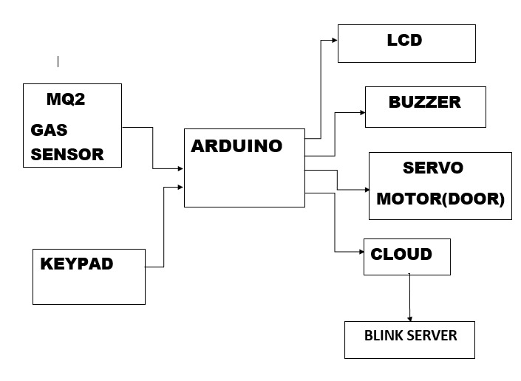**BLOCK DIAGRAM:**

**FLOWCHART:**

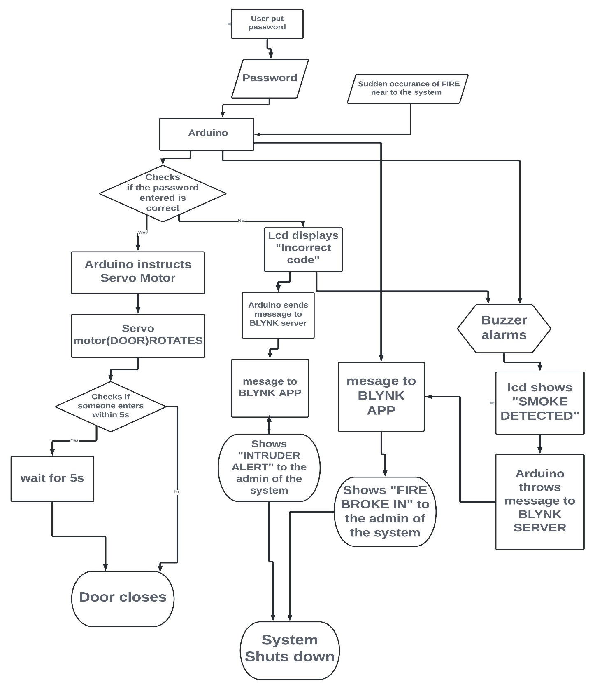

**CIRCUIT DIAGRAM:**

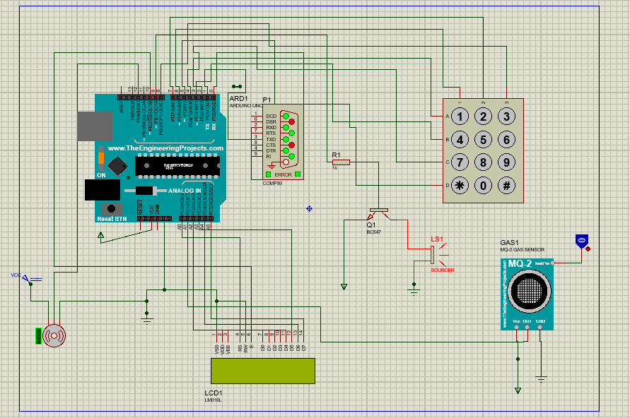

**COMPONENTS LIST:**

1. Hardware Components:

* Arduino Uno
* LCD for display
* Keypad
* BC 547 npn Transistor for Switching
* LS1 buzzer
* Servo Motor
* MQ2 Gas Sensor
* Compim

1. Software Components:

* Arduino IDE
* Proteus Simulator
* VSPE(Virtual Serial Port Emulator) for pairing of COM pins
* Blynk Mobile App

**CONCLUSION**

The Smart security system works as follows:

1. An individual who has the authorized codes approved by the Admin can only be given access to their house, though the activation is granted for few seconds customizable by the admin after that allotted time, the lock is re-initialised with the help of the Servo Motor working.
2. If someone tries to enter using a wrong passcode or hit and trial method a notification will be sent to the admin through the Blynk app alerting them of the situation
3. It also has some additional feature like Gas detection, if there’s a fire break out or any surge in the gas level in the house or in the vicinity of the app an alert message will be sent to the admin through the app

In today’s technologically advanced world, autonomous systems are gaining rapid popularity so the advancement in latest technology is continuously and rapidly made on different latest automatic door lock security systems. The need for an advanced door lock security systems using new technologies is increasing day by day as security become a very important or serious issue for everybody. Due to the recent trends in various methods of security for home, buildings, companies, vehicles etc. there is no need to worry about this security any longer, as automatic security systems are here to deal with it.

Also due to the current Pandemic situation, Theft is on a rapid rise so smart security system judging from current scenario is of utmost importance. And people are investing heavily in all types of security as in current age where we all leave a digital footprint behind, the scope of this security device is unlimited and can be dyed into further higher security

**FUTURE SCOPE:**

Future scope for the SMART SECURITY SYSTEMS involves making homes, properties etc. even smarter. It can be interfaced with sensors including motion sensors, light sensors and temperature sensors and provide automated toggling of devices based on conditions. The system can be integrated closely with home security solutions to allow greater control and safety for home or property owners. The next step would be to extend this system to automate a large scale environment where a stringent security is a must such as offices, banks and factories. SMART SECURITY offers a global standard for interoperable products. Standardization enables smart security that not only focus on security but also it will be able to control appliances, lighting, environment and energy management as well as the expandability to connect with other networks.